INSY 4305/5352 Assignment #2

Write a program that displays a circle of given size and calculates and displays the area, radius, diameter, and circumference. Use the following equations:

*diameter = 2(radius)  
area = (Math.PI)(radius)(radius)   
circumference = 2(Math.PI)(radius)*

The user should be able to alter the radius with a **JSlider**. The program should work for radii in the range of 100 to 200. As the radius changes, the diameter, area, and circumference should be updated and displayed. The initial radius should be 150. All the drawing should be done on a subclass of **JPanel**, and the results of the calculations should be displayed in a read-only **JTextArea**.

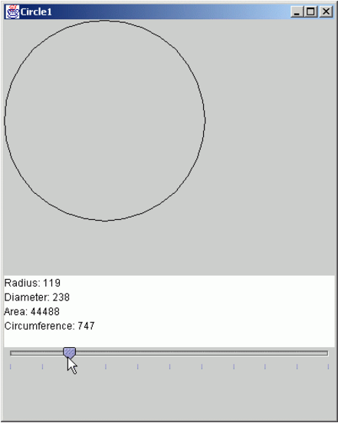**Note:**  
1. You need to write your own subclass of **JPanel** that implements the dedicated drawing area in the application. However, for this assignment, do not write the **JPanel** subclass in a separate file. Include it in your application file as a separate class but make sure you DO NOT use the access modifier **public** for the **JPanel** class (remember, you can only have ONE public class per file). You should name this file HW2.java